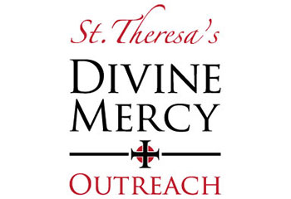

**MERCY IN ACTION**

**St. Theresa Parish Divine Mercy Outreach**

**2023 ASSISTANCE GIVEN: $ 221,477.**



66317

|  |  |
| --- | --- |
| DivMercy | **Rental Assistance: $115,380.**  Provided to individuals and families, including veterans, who found themselves faced with an eviction notice or who could not meet their monthly rent due to the loss of a job, illness, or other emergency situations. |
| **Beds and Cribs: $32,350.**  Due to your generosity, **119** men, women, and children who were sleeping on the floor every night were provided with beds/cribs, sheets, comforters or blankets, and pillows. | |
| **Utility Assistance: $39,864.**  Provided to individuals and families who had been served with a termination of service notice or whose electricity, gas, or water had been turned off due to unforeseen financial emergencies, loss of job, illness, etc. | |
| **Miscellaneous Assistance: $20,828.**  • Automobile repairs for needy working individuals and veterans  • Funeral expenses for low income expectant mom with twins  • Medical expenses for those without medical or dental insurance  • For disabled children  • Financial assistance for those dealing with cancer or other terminal illness, death of a child or a parent, individuals dealing with disabilities, veterans, single parents struggling financially on only one income, etc. | |
| **Gift Cards: $13,055.**  Provided to individuals & families in need to assist with the cost of groceries, gas, clothing, and other necessities of life that they could otherwise not afford. | |



The above monetary numbers do not include the numerous donations of food, furniture, diapers, toiletries, clothing, bedding & misc. items that have been donated & given to families in need throughout the past year by our generous supporters and items given through consignment sale vouchers.

