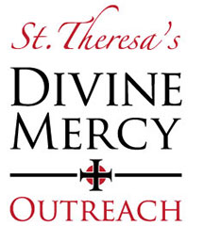
MERCY IN ACTION
St. Theresa Parish Divine Mercy Outreach
2019 ASSISTANCE GIVEN: $209,219
Over 854 requests for assistance

66317

Rental Assistance : $110,374

Provided to individuals and families who found themselves faced with an eviction notice or who could not meet their monthly rent due to the loss of a job, illness, or other emergency situations.
Beds, Cribs, Bedding and Pillows: $29,648

Due to your generosity, 153 men, women, and children who were sleeping on the floor every night were provided with beds/cribs, sheets, comforters or blankets, and pillows.
Utility Assistance: $33,392

Provided to individuals and families who had been served with a termination of service notice or whose electricity, gas, or water had been turned off due to unforeseen financial emergencies, loss of job, illness, etc.
Miscellaneous Assistance: $19,102

• Automobile repairs for needy working individuals
• Eye glasses for elementary student, bike for adult transportation to work

• Medical expenses for those without medical or dental insurance

• Assistance for disabled children

• Financial assistance for those dealing with cancer or other terminal illness, death of a child or a parent, individuals dealing with disabilities, single parents struggling financially on only one income, etc.
Gift Cards: $16,703

Provided to individuals & families in need to assist with the cost of groceries, gas, clothing, and other necessities of life that they could otherwise not afford.
The above numbers do not include the numerous donations of food, tables & chairs, diapers, toiletries, clothing, bedding & misc. items that have been donated to Divine Mercy Outreach throughout the past year by our generous supporters.

