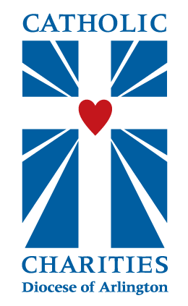
St. Theresa Catholic Church, Catholic Charities, and Britepaths
~ Invite You to Attend ~
FREE
Budgeting & Money Management Workshop
7:00 p.m. – 9:00 p.m.
Thursday, February 22nd
St. Theresa Catholic Church
21370 St. Theresa Lane, Ashburn, VA 20147
Are you tired of trying to make ends meet? Don't have a monthly budget? Want to plan for a better future for you and your children? This FREE workshop is for you!
Topics will include:
- Identify tools to help you manage your money
- Prepare a personal spending plan or budget
- Estimate monthly income and expenses
- Identify ways to decrease spending and increase income
- Set financial goals
- Strategize how to reduce debt
This workshop is for all who are interested in better managing their finances. Great for single parent families, couples, seniors on fixed incomes and young adults out in the workplace for the first time.
All are welcome, regardless of religious affiliation. Bring a friend!
Attendance is free and you can show up at the door, but we highly encourage you to RSVP at bit.ly/finwkst- Thank you!

Catholic Charities of the Diocese of Arlington is partnering with Britepaths to bring these financial workshops to the Diocese of Arlington.

