BRHS Senior Capstone
HELP FAMILIES IN NEED BY DONATING TOILETRIES!
We (2 Seniors) are collecting items to help struggling families.
DONATIONS WILL GO TO DIVINE MERCY OUTREACH - A PROGRAM THAT ASSISTS LOW INCOME AND HOMELESS INDIVIDUALS/FAMILIES
IN LOUDOUN COUNTY
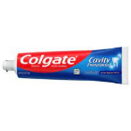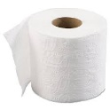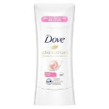

PLACE ITEMS IN THE PLASTIC BAG ATTACHED AND PUT ON FRONT PORCH/STOOP MAY 25TH BEFORE 2PM

Items Needed (New only):
*moisturizing lotion *men's and women's deodorant *children's toothbrushes and toothpaste *adult toothpaste *shampoo & conditioner * body wash *baby shampoo & baby wash * liquid hand soap *hand sanitizer *women's shavers *bars of soap *facial soap *toilet paper *tissues *paper towels *laundry soap *dish soap *dishwasher soap *bathroom cleaners (toilet bowl cleaner, Windex, Scrubbing Bubbles, Clorox wipes, etc.)
*unused and unexpired items only*
Questions? Contact us through dmoassistant@sainttheresaparish.com
For more information contact about Divine Mercy Outreach contact: 703-729-2334 or dmoutreach@sainttheresaparish.com
Or visit the website www.sainttheresaparish.com under Outreach

